**DEPARTMENT OF INFORMATION TECHNOLOGY**

**COURSE CODE: DJS22ITL307 DATE: 29/10/23**

**COURSE NAME: Web Programming Laboratory CLASS: SY BTech**

|  |
| --- |
| NAME: Ayush Vinod Upadhyay  ROLL NO: I025  SAP ID: 60003220131  BRANCH: Information Technology  BATCH: 1 |

**EXPERIMENT NO. 4**

**CO/LO:** Develop web applications.

**AIM / OBJECTIVE:** Design a website using Tail Wind CSS.

**THEORY:**

Tailwind is a Utility css framework for quickly creating user interfaces

Tailwind is modern opensource framework for developing web applications using CSS only, Javascript is not required. It is developed based on flexbox

Tailwind framework is easy to use and strong documentation provided. **Features and advantages**

* Easy to use and simple to learn
* Opensource and support major browsers
* Mobile first design
* Flexbox integrated grid system
* Responsive design
* Modular - use required features only
* NPM integration
* It supports modular design
* SASS and SCSS support
* Customization is very easy
* Javascript is not required, Everything is coded in CSS

**Disadvantages**

* performance and compatible issues in IE11
* It is new entrant and not large community compared with other frameworks • framework is in development, final version is in processing

**Explain all the classes used in the code**

* **flex h-screen**: Flex container with full height.
* **.w-full bg-purple-500 flex items-center justify-center**: Full-width, purple background, flex container with centered content.
* **.text-4xl font-bold**: Text size 4xl and bold font.
* **.mt-2 text-gray-400:** Top margin 2 units, text color gray-400.
* **.flex flex-col items-start**: Flex container with column direction, items aligned to the start.
* **.mt-20 flex w-full justify-evenly gap-5:** Top margin 20 units, full-width flex container, evenly spaced with a gap of 5 units between items.
* **.rounded-lg border-2 border-gray-200 px-4 py-2 outline-none:** Rounded corners, 2px gray border, padding-x 4, padding-y 2, no outline.
* **.mt-6 w-full :** Top margin 6 units, full-width.
* **.bg-purple-500 text-white px-24 py-3 rounded-lg fontbold:** Purple background, white text, padding-x 24, padding-y 3, rounded corners, bold font.
* **.bg-[#312e81] text-white px-2 py-4:** Background color #312e81, white text, padding-x 2, padding-y 4.
* **.font-bold text-xl:** Bold font, text size xl.
* **.flex mt-4 font-semibold gap-5:** Flex container with top margin 4 units, semi-bold font, gap of 5 units between items.
* **.text-sm:** Text size small.
* **.w-80 mt-4:** Width 80 units, top margin 4 units.
* **.px-2 py-4:** Padding-x 2, padding-y 4.

**Code:**

**1)**

<div class="flex h-screen">

<div class="w-full bg-purple-500 flex items-center justify-center"><img src=https://cdni.iconscout.com/illustration/premium/thumb/login-page-4468581-

3783954.png?f=webp></div>

<div class="flex w-full flex-col items-center justify-center bg-gray-100 py-12">

<h1 class="text-4xl font-bold">REGISTER</h1>

<p class="mt-2 text-gray-400">Enter your information to register</p>

<div class="flex flex-col items-start">

<div class="mt-20 flex w-full justify-evenly gap-5">

<div class="flex flex-col">

<label class="text-sm font-semibold text-gray-500" for="fname">First name</label>

<input type="text" placeholder="John" class="rounded-lg border-2 border-gray-200 px-4 py-2 outline-none" />

</div>

<div class="flex flex-col">

<label class="text-sm font-semibold text-gray-500" for="lname">Last Name</label>

<input type="text" placeholder="Smith" class="rounded-lg border-2 border-gray-200 px-4 py-2 outline-none" />

</div>

</div>

<div class="flex flex-col mt-6 w-full">

<label class="text-sm font-semibold text-gray-500" for="lname">Email</label>

<input type="email" placeholder="johnsmith@example.com" class="rounded-lg border-2 border-gray-200 px-4 py-2 outline-none" />

</div>

<div class="flex flex-col mt-6 w-full">

<label class="text-sm font-semibold text-gray-500" for="lname">Password</label>

<input type="password" placeholder="**********" class="rounded-lg border-2 border-gray200 px-4 py-2 outline-none" />

</div>

</div>

<button class="mt-12 bg-purple-500 text-white px-24 py-3 rounded-lg fontbold">REGISTER NOW</button>

</div>

</div>

**2)**

<nav class="bg-[#312e81] text-white px-2 py-4">

<h1 class="font-bold text-xl">My landing page</h1>

<div class="flex mt-4 font-semibold gap-5">

<p>Home</p>

<p>About</p>

<p>Services</p>

<p>Contact</p> </div>

</nav>

<div class="px-2 py-4">

<h1 class="font-bold text-xl">Hello World</h1>

<p class="text-sm">Nature, in the broadest sense, is the physical world or universe. Nature’ can refer to the phenomena of the physical world, and also to life in general. The study of nature is a large, if not the only, part of science. Although humans are part of nature, human activity is often understood as a separate category from other natural phenomena.</p>

<div class="w-80 mt-4">

<img

src="https://as1.ftcdn.net/v2/jpg/02/86/72/18/1000_F_286721823_jX2eKauNsttWhIxKAzPYhH wYpSRTCdcm.jpg" alt="Waterfall Pic" >

</div>

<p class="text-sm mt-4">Shaki Waterfall (Armenian: Guiphh gnutid) is a waterfall in Armenia. with a height of 18 m. It is located in Syunik Province.[1] The Shaki Waterfall is situated 6 km from the town of Sisian. On the left side of the river Vorotan's gorge, basalt lava flows have solidified to form a ledge 18 meters high from which the waterfall cascades down.</p> </div>

**Example:**



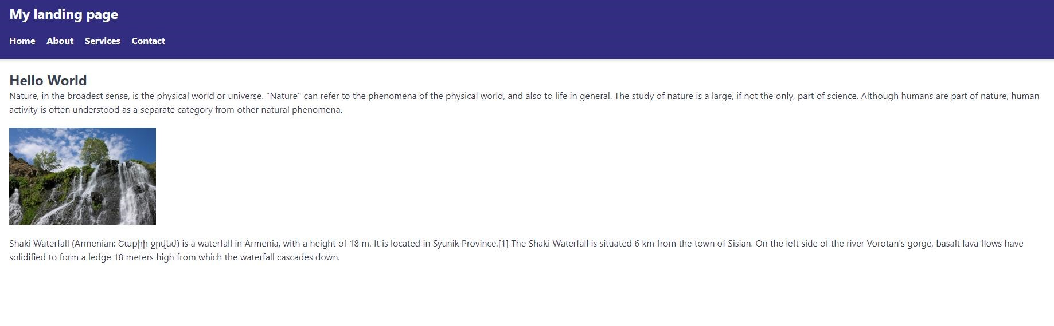

**Output:**



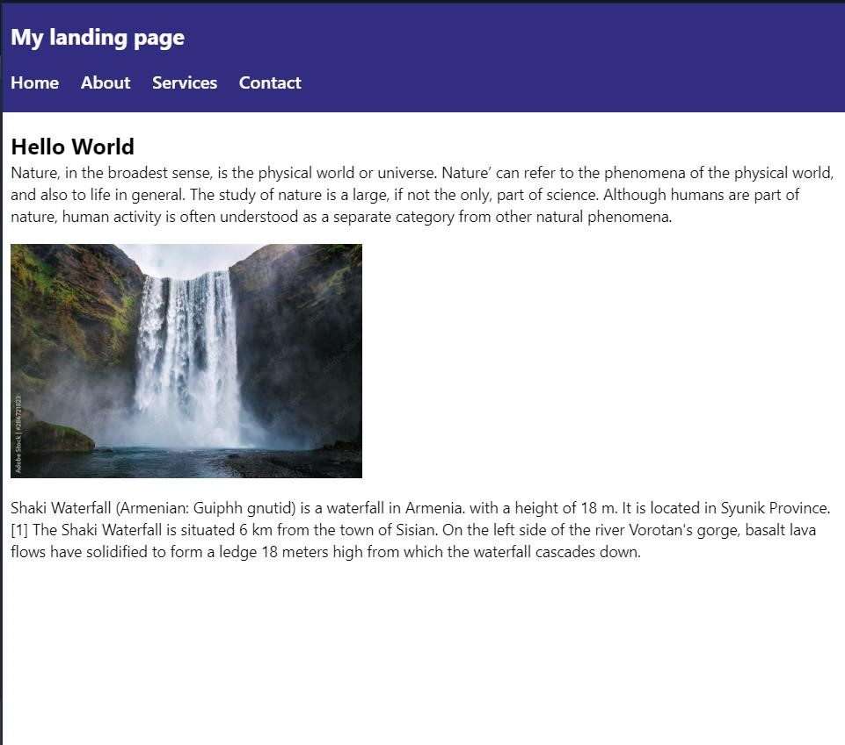

**CONCLUSION:** I learnt and used various classes of tailwind css and understood how it can be usefull in applying styling without using css and writing very less code. I remembered various class names and their functions that I learned from tailwind css website.

**BOOKS AND WEB RESOURCES:**

1. Tailwind CSS From Scratch | Learn By Building Projects by Brad Traversy
2. Tailwind CSS: A Modern Way To Build Websites Using CSS